**Description:**

Loyal Oni. Guard of the lost Yamagami Clan. Tragedy struck when they lost the Di Manes Hana, the bride of the head of the Yamagami Clan, and got invaded by the pawns of the 6th Hero and the Invading God.

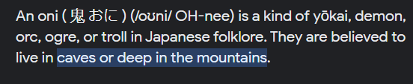 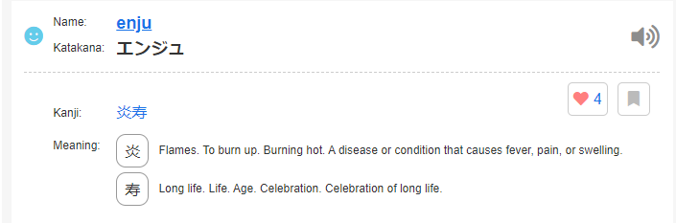 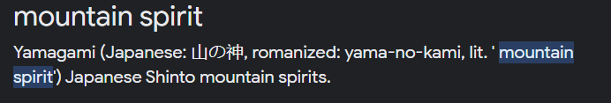

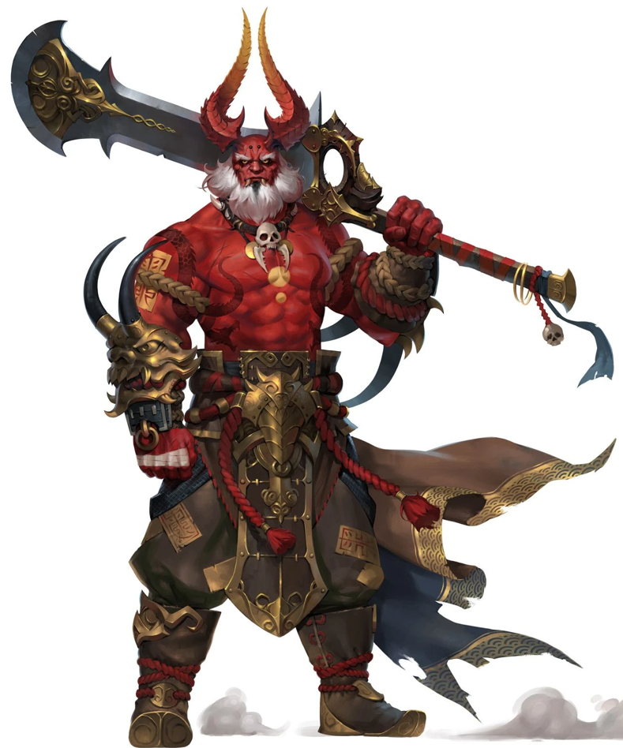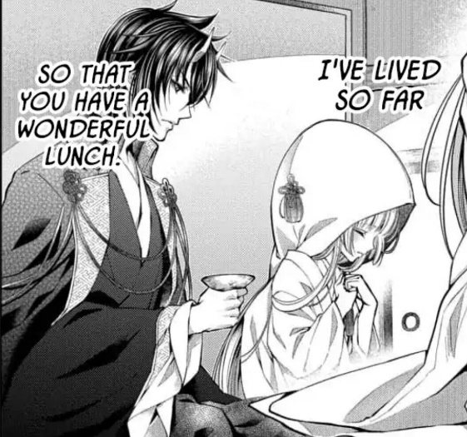

(manga src from The Demon’s Bride Wants to be Eaten)

**Soul:**

**Abilities:**

**Weapons:**

**Physical Details:**

Age A

Gender A

Race/Heritage A

Height A

Weight A

Body Posture and Bearing A

Distinguishing Marks A

Physical Challenges A

Overall Condition and Presentation A

Clothing Style Preferences A

Common Adornments A

**Daily Life:**

*Family and General Life*

A

*Talents and Skills*

A

*Occupation*

A

*Hobbies*

A

**Backstory:**

<Summary>

*Wound*

A

*Fear*

A

Because of these:

*Lie*

A

*Secrets*

A

**Personality:**

*Positive Traits*

Influencers/Role Models

A

Past Achievements and Sources of Pride

A

Ethics and Values

A

Environmental Contributions

A

Traits

A

*Negative Traits*

Bad Influencers/Role Models

A

Unjust/Unfair Experiences

A

Painful Memories

A

Negative Life Lessons

A

Traits

A

**Behavior:**

*Core Behavior*

A

*Emotional Range*

Idle: A

Stressed: A

Exhausted: A

Inebriated: A

Overstimulated: A

Anxious: A

Distracted: A

Bored: A

Attraction: A

Aroused: A

X

X

X

X

X

*Negative Coping Mechanisms*

A

*Positive Coping Mechanisms*

A

*Uncomfortable Emotions*

A

*Quirks*

A

**Motivations:**

*Outer Motivation*

A

*Inner Motivation*

A

*Emotional Shielding*

A

*Fatal Flaw*

A